
HDOC day 23
Write a C program that displays the following menu and uses a switch statement to print the
basic
square/rectangular pattern selected by the user. Use nested loops without arrays. Each pattern
may be implemented
in a separate parameterless function with no return value.
Note: For each activity, prepare the algorithm and test-case table. Then write, compile and
execute the C program,
and test it against the prepared test cases.
1) question 1)
1. Solid square pattern
Input the number of rows, n, and print a solid square pattern containing n rows and n columns.
For n = 4:
* * * *
* * * *
* * * *
* * * *
Aim: To write a C program to print a solid square pattern of n rows and n columns using nested
loops.
Algorithm – Solid Square Pattern
Start.
Input number of rows n.
Use outer loop from i = 1 to n.
Use inner loop from j = 1 to n.
Print * in each column.
Move to next line after each row.
Stop.
C code
#include<stdio.h>
int main()
{
int n,i,j;
scanf("%d",&n);
for(i=1;i<=n;i++)
{
for(j=1;j<=n;j++)
printf("* ");
printf("\n");
}
return 0;
}
Test case table

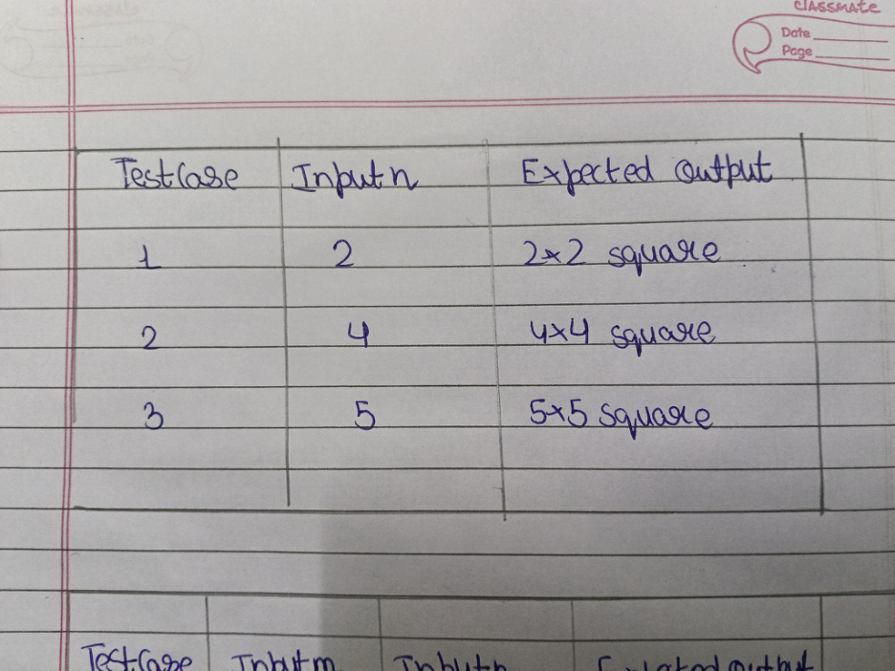

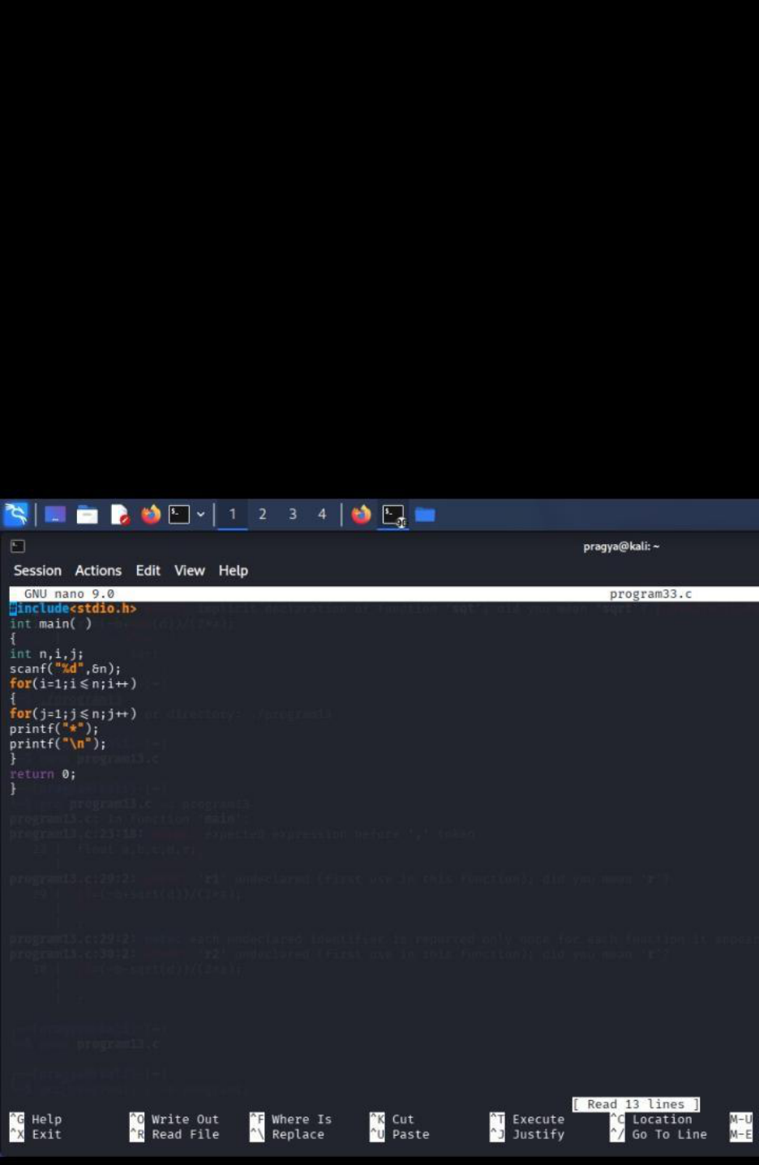



2)Aim: To write a C program to print a solid rectangular pattern of m rows and n columns using
nested loops.
Algorithm
1)start
2)input rows m and coloum n.
3)Run outer loop from i = 1 to m.
4)Print * in each column.
5)Move to the next line after each row.
6)Stop.
C code
#include<stdio.h>
int main()
{
int m,n,i,j;
scanf("%d%d",&m,&n);
for(i=1;i<=m;i++)
{
for(j=1;j<=n;j++)
printf("* ");
printf("\n");
}
return 0;
}
Test case table

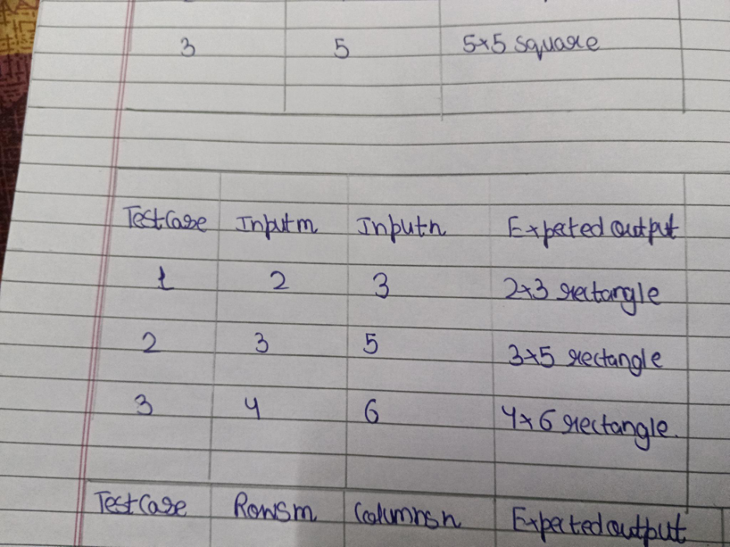

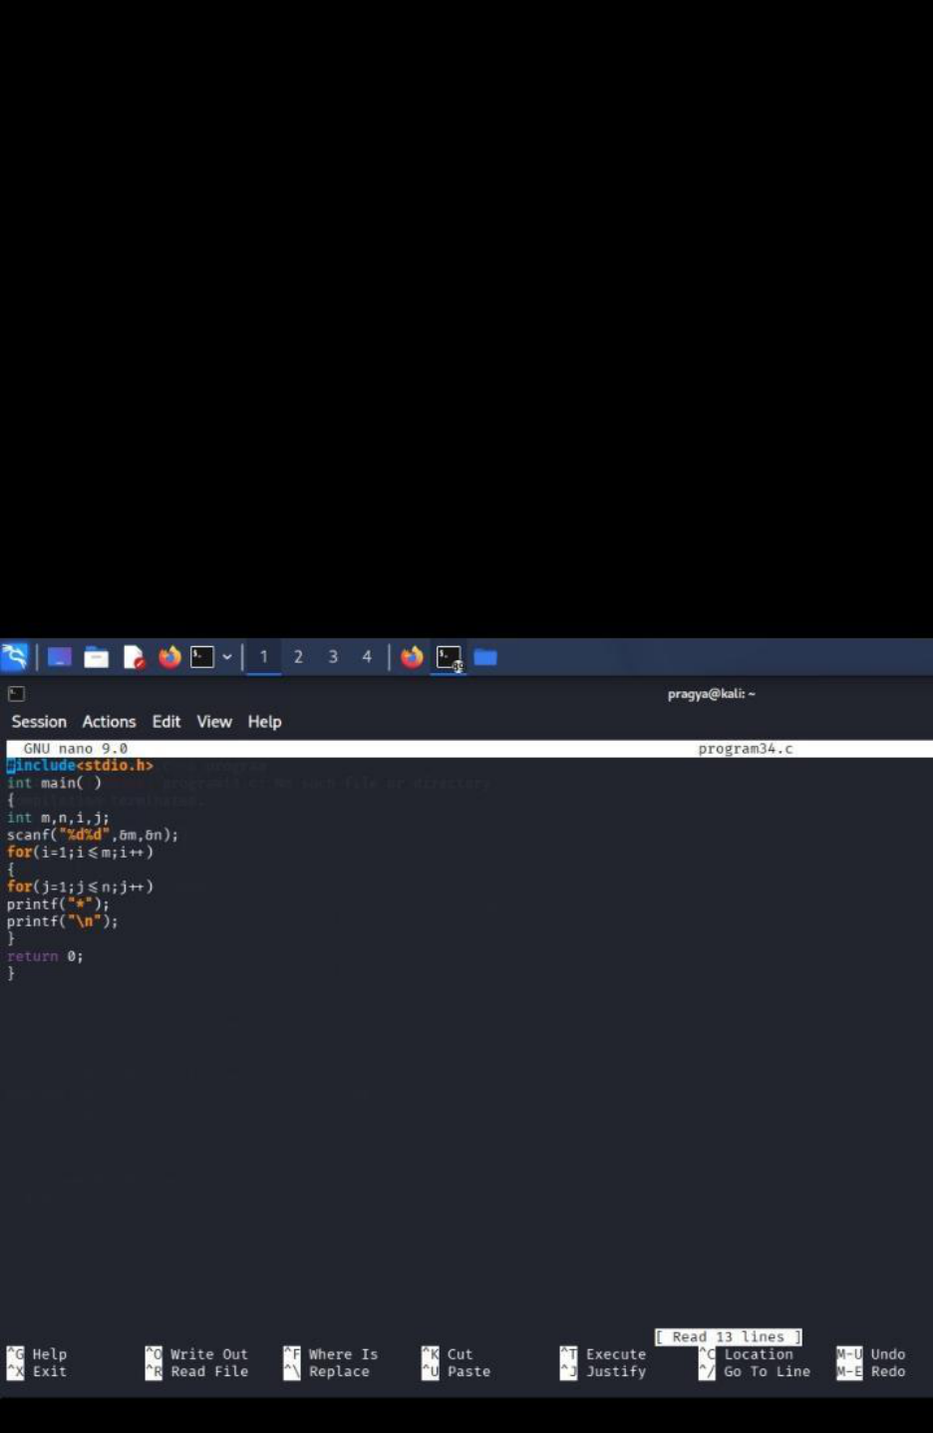



3)Row-number pattern
Input the number of rows, m, and columns, n. Print a rectangular number pattern in which every
element in a
row is equal to its row number.
For m = 4 and n = 4:
1 1 1 1
2 2 2 2
3 3 3 3
4 4 4 4
C code
#include<stdio.h>
int main()
{
int m,n,i,j;
scanf("%d%d",&m,&n);
for(i=1;i<=m;i++)
{
for(j=1;j<=n;j++)
printf("%d ",i);
printf("\n");
}
return 0;
}
Test case table

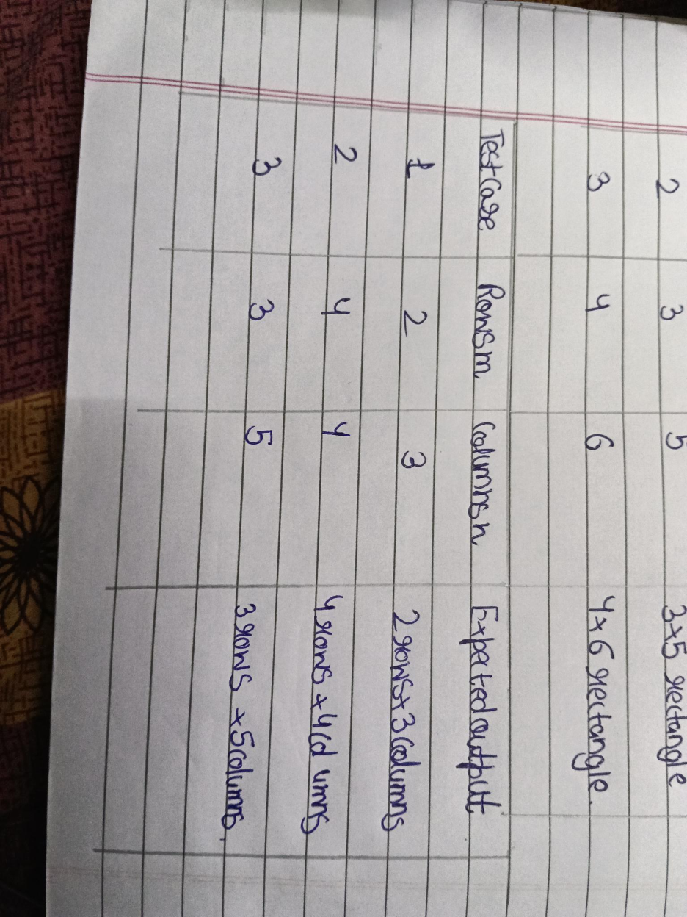

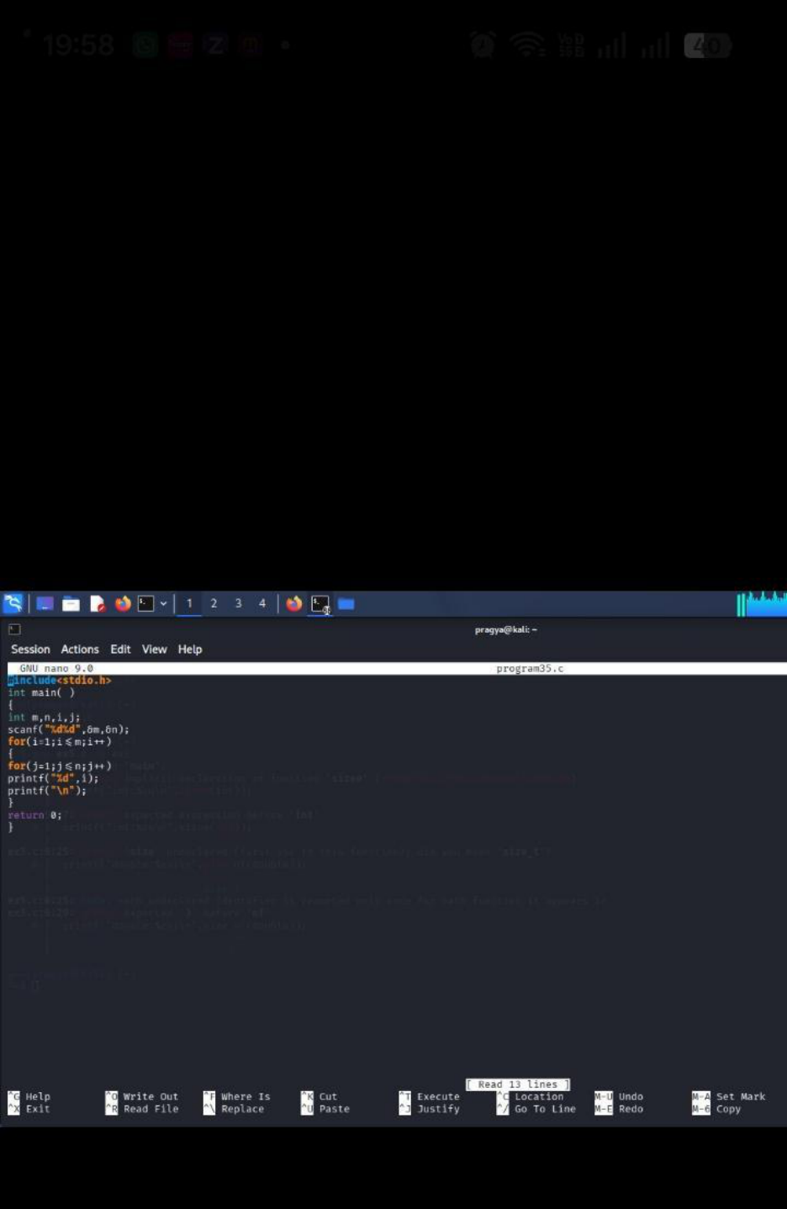



4). Column-number pattern
Input the number of rows, m, and columns, n. Print a rectangular number pattern in which every
element in a
column is equal to its column number.
For m = 4 and n = 4:
1 2 3 4
1 2 3 4
1 2 3 4
1 2 3 4
Algorithm
1)Start.
2)Input rows m and columns n.
3)Run outer loop from i = 1 to m.
4)Run inner loop from j = 1 to n.
5)Print column number j.
6)Move to the next line after each row.
7)Stop.
C code
#include<stdio.h>
int main()
{
int m,n,i,j;
scanf("%d%d",&m,&n);
for(i=1;i<=m;i++)
{
for(j=1;j<=n;j++)
printf("%d ",j);
printf("\n");
}
return 0;
}

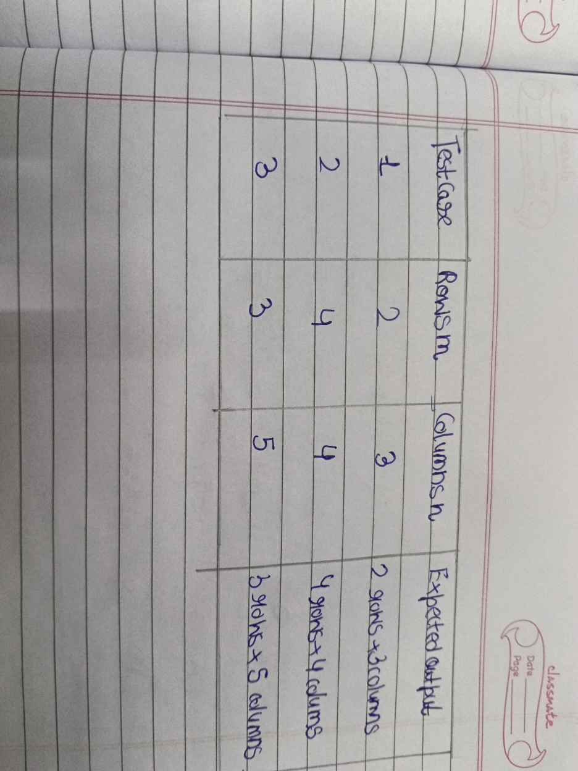

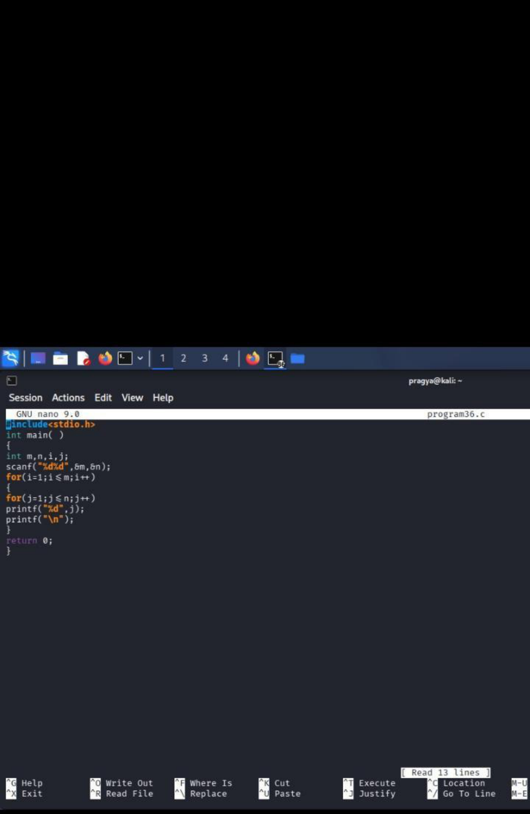

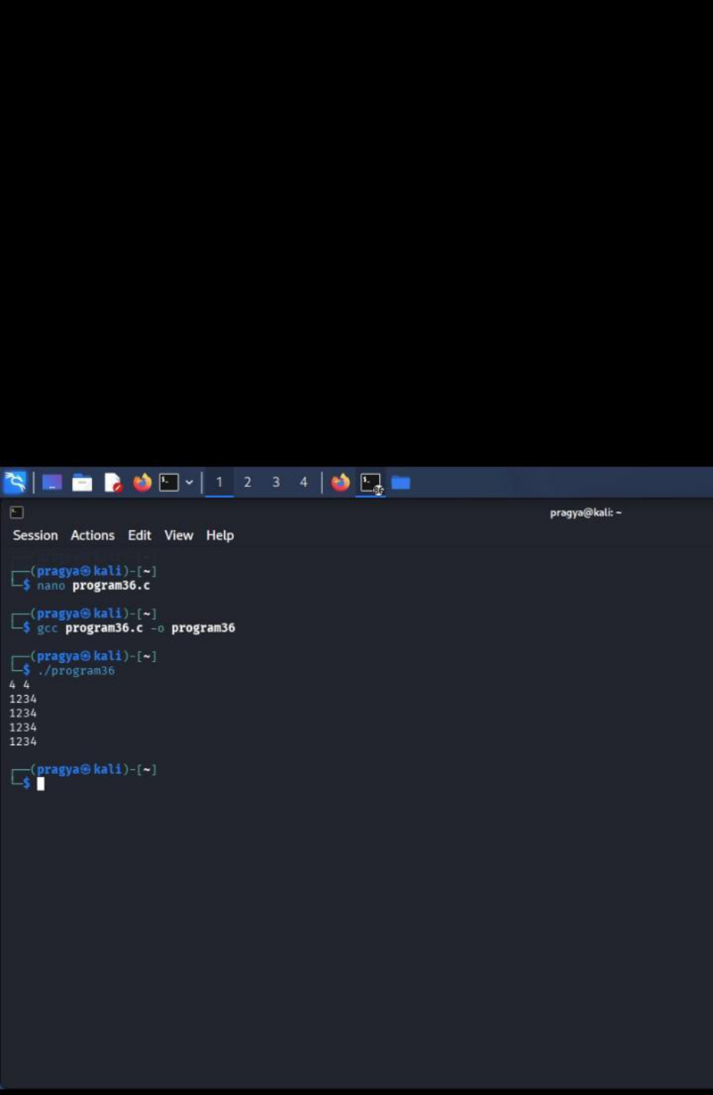

Result: The program successfully prints the column-number pattern using nested loops.
Thank you
Pragya pandey
Batch 15
Sap id 590034352

